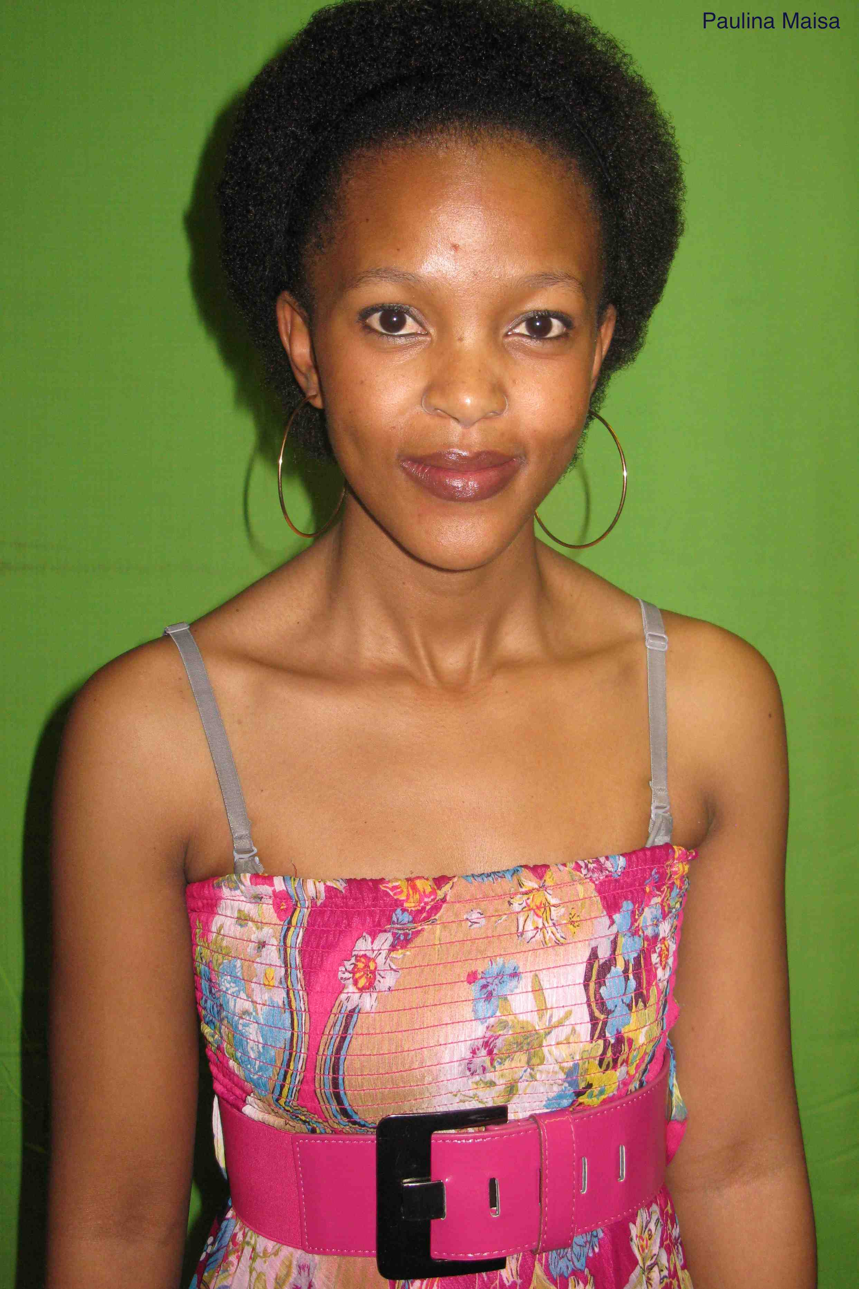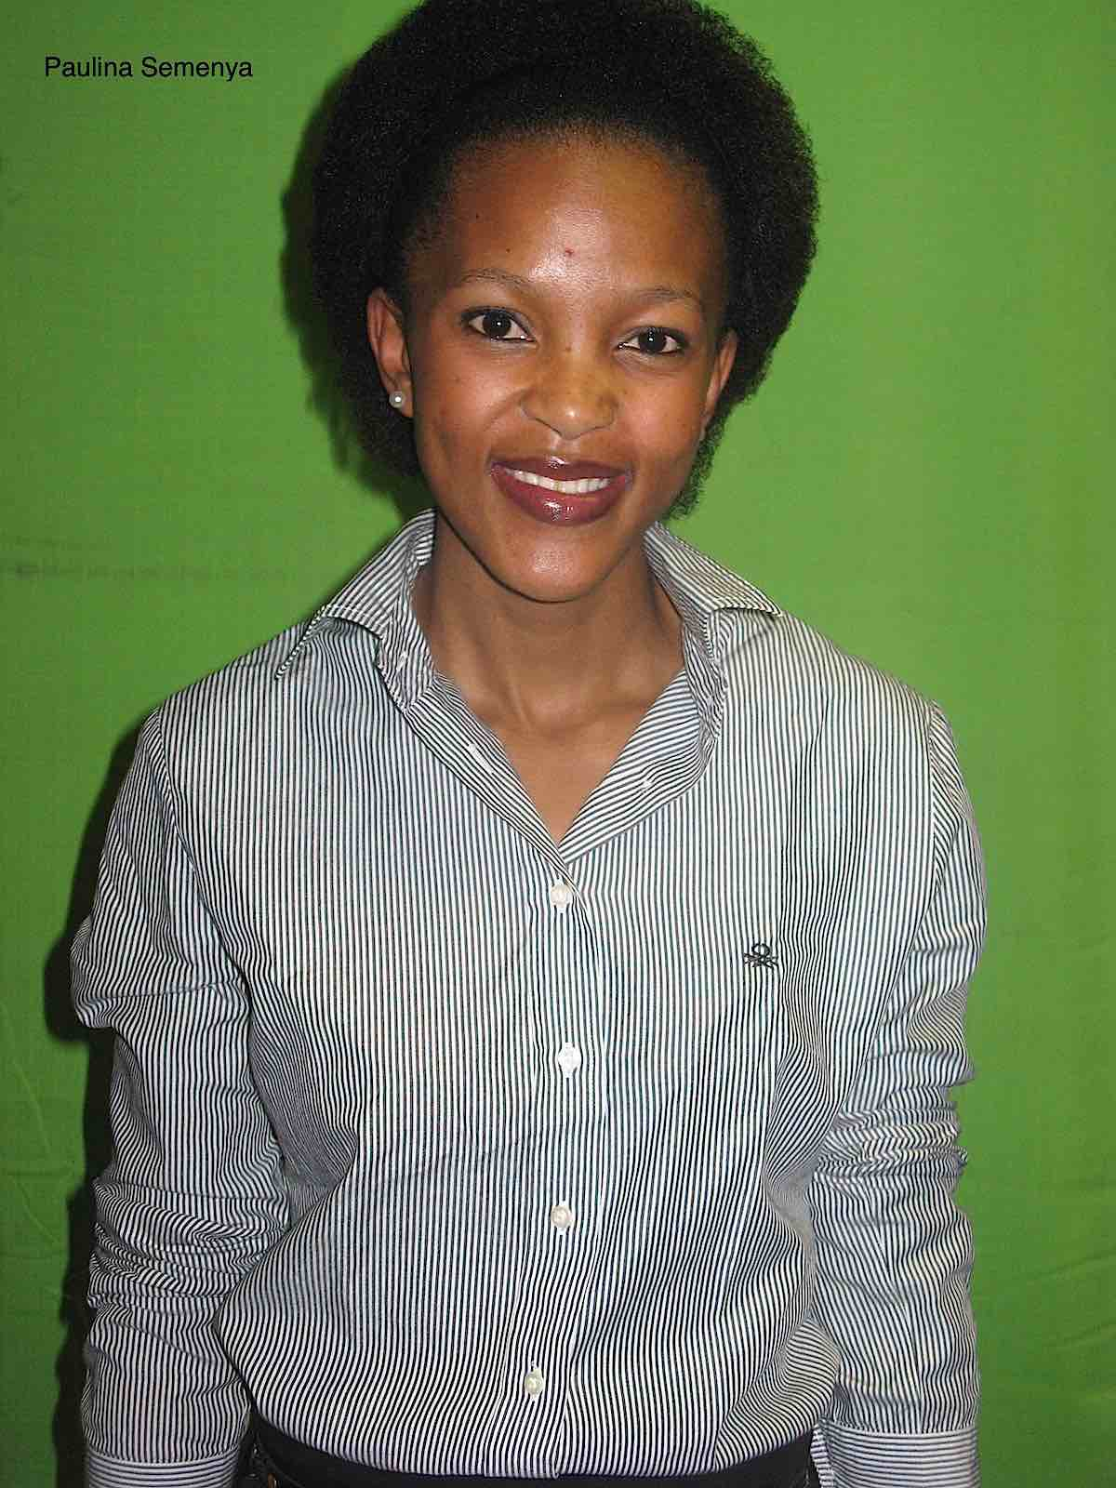

Actor’s Profile
NAME: Paulina Maisa Semenya
ARTIST NAME: Maisa
AGENCY CAST AFRICA
CONTACT Charles +2783 9517485
Email address charles@castafrica.net
PROFFESSION Acting, Presenting, Stage performer
LANGUAGE SPEAKING Sepedi, Zulu, English, Afrikaans
QUALIFICATIONS Speech & Drama, Dance, Singing
Training Institution Market Lab, Victory Sonqoba Theatre

EXPERIENCE:

ROLE PRODUCT COMPANY DESCRIPTION
Connie Scandal Ocrhe Media E-tv daily soap
Sthoko TURFLOOP Peu Commication TV Drama Series
Play Kuku Roof Bongani Linda Stage Play
Play Behind the curtains Bongani Linda Stage Play
Play Dark City Bongani Linda Stage Play
Play The Truth Bongani Linda Stage Play

